PIC25FJ32GB002 (and similar / compatible devices)

Set the QuickDev Board jumpers in position “PIC24F”.
Plug the PIC in the socket.
Connect the PICKit TO QuickDev Board.
Open MPLAB IPE.
In Device option, select the PIC model.
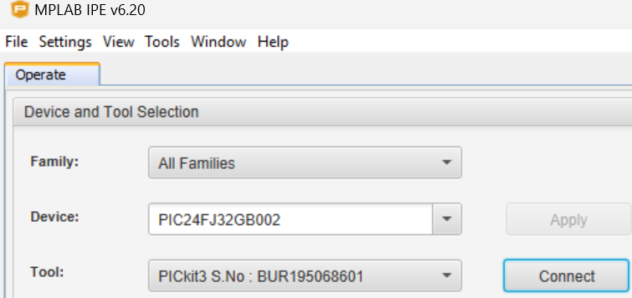
External power is not required to program this PIC - under Power Settings, enable PICKit to power the circuit.
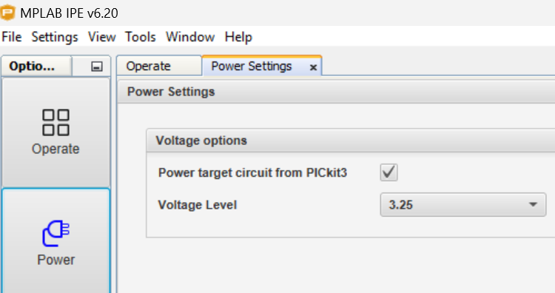

Connect.
Browse to the folder with the file to program into the PIC and load it
Program.

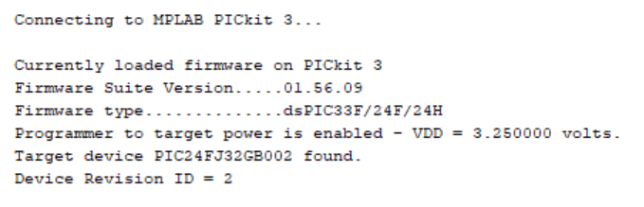
The demo program blinks LED in the QuickDev Board (PIN RB4), which is also available in the pin header .
The push button is connected to PIN RA0, when pressed will make the led blink faster.

PIC16F1459 and PIC16F84
Set the QuickDev Board jumpers in position “PIC16F14” when programming PIC16F1454, PIC16F1455 or PIC16F1459.

Set the QuickDev Board jumpers in position “PIC16F84” when programming PIC16F84 or PIC16F84A.

These PIC will need external power supply connected to the board. Also disable the option to power the circuit in the MPLAB IPE.

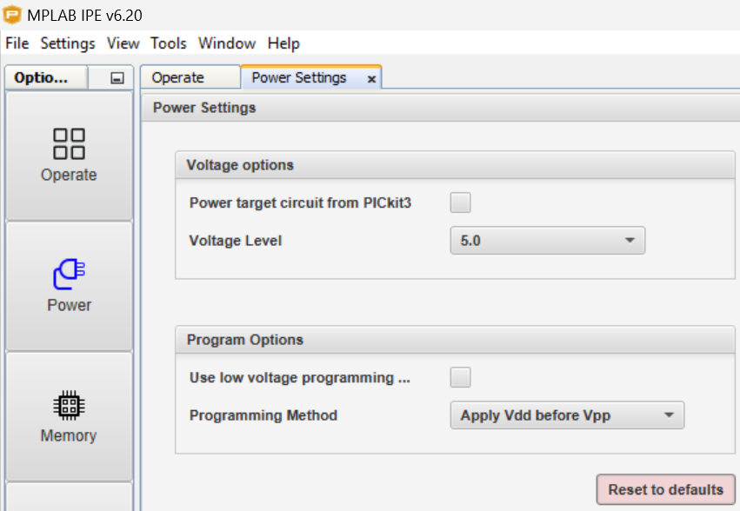
A successful connection to PIC16F1459 will display the following information.
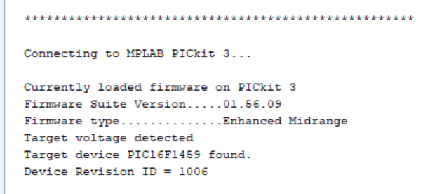

A successful connection to PIC16F84 will display the following information.
